Sentiment Analysis in Twitter
- Overview
Sentiment analysis, also known as opinion mining, describes the tasks to systematically identify, extract, quantify, and study affective states and subjective information. It is widely applied to customer reviews, survey responses, and social media. Understanding the emotion of Twitter users will enable researchers to grasp the trend of public opinion towards certain topics. This has many applications in political science, social science, market research, psychology and public health study.
The SMILE application is capable to perform sentiment analysis on both the individual tweet as well as the tweet collections grouped by user’s search term. The Valence Aware Dictionary and Sentiment Reasoner algorithm is being used. It is a rule-based model catering to assess the sentiment of tweets.
Tweets

Downloadable Results

Sentiment visualization

VADER
This is generated when the user specifies a term to search in the “social media search” page and is saved on user's home directory.
The Vader algorithm in Python NLTK library has been used here.
Downloadable and visualization is available in the “sentiment analysis” web page.

Figure 1. Overall workflow of sentiment analysis

- Tweet processing
The data fetched from twitter's RESTful API and our elasticsearch archive has been transformed to a tabular format (.csv) with each column represents a field, and each row represents an individual tweet/record. These data have been stored in the session folder under each user's home directory and the SMILE application creates an interface to interact with those data. In the "Sentiment Analysis" web page and under the configuration panel, there's a drop-down box named "select from your folder" which lists all the available Twitter data on disk; once a twitter file has been selected, a preview will appear with the columns which Sentiment Analysis could be applied to (Figure 2).
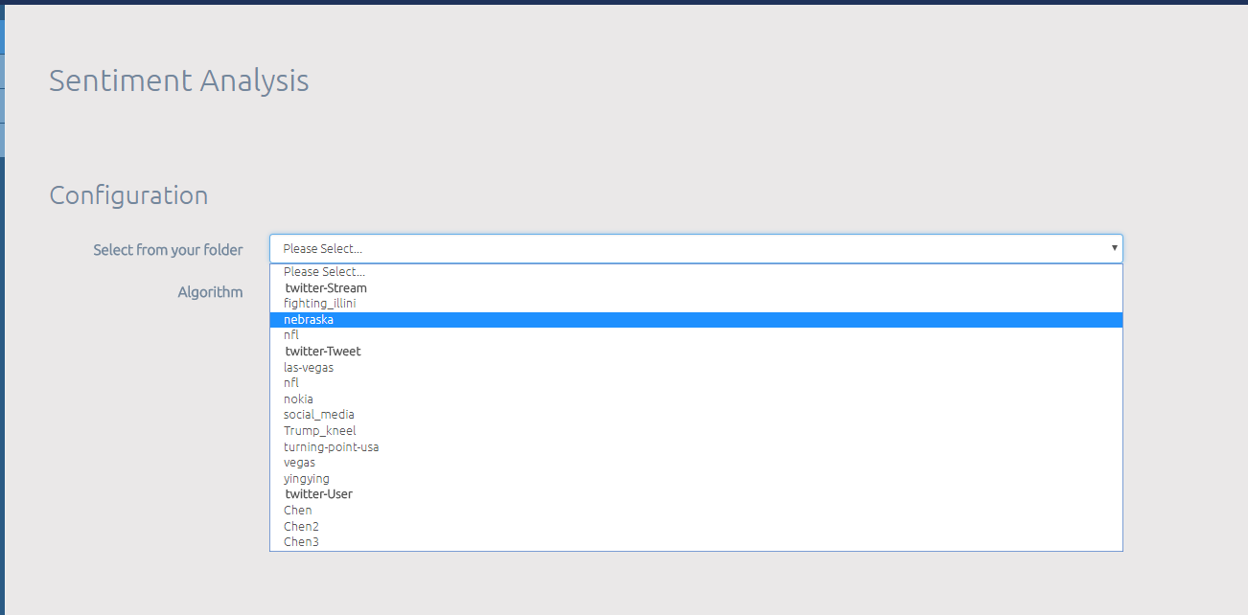
Select twitter Data available to perform sentiment Analysis on
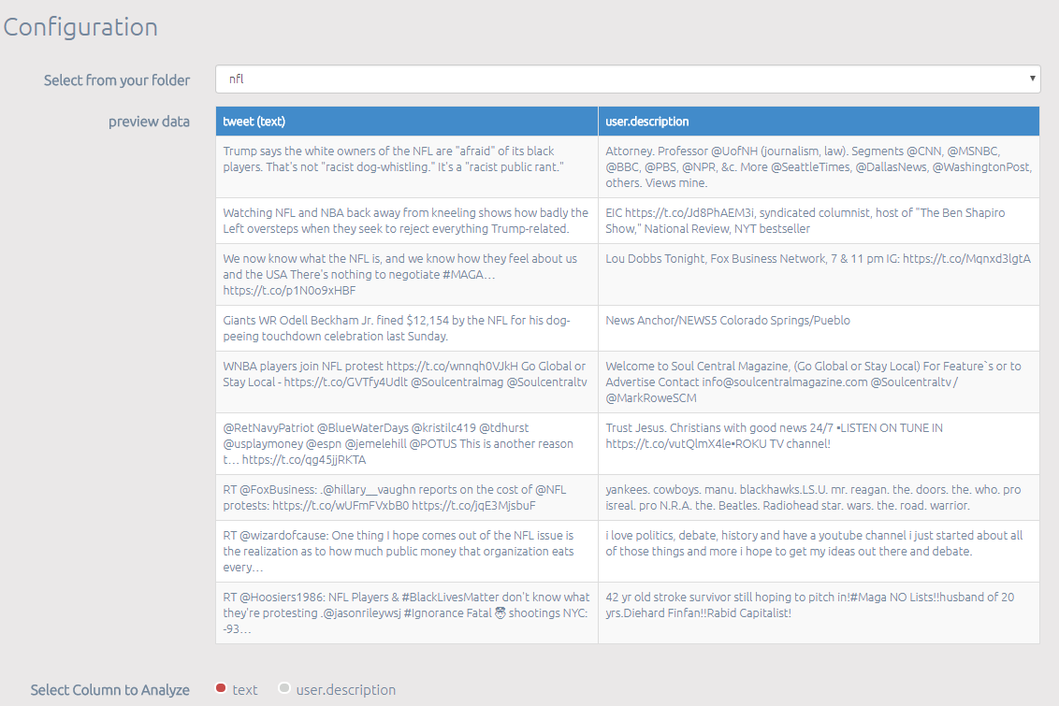
For tweets, you can choose to perform sentiment analysis on either “tweet text”, or on author’s description
Figure 2. Select twitter data and its field to perform Sentiment Analysis

- Aggregated Sentiment vs. Tweet Sentiment
For aggregated Sentiment, first of all, we concatenate each row of the selected field into one single document. Then Vader algorithm will be performed on this aggregated document. VADER produces four sentiment metrics: Neutral, negative and positive scores represent the proportion of the text that falls into those emotions, and should add up to 100%. The compound score is the sum of all the lexicon ratings which have been standardized to range between -1 and 1. The score that is closer to -1 indicates strong negative emotion, while closer to +1 indicates positive emotion. The Neutral, negative and positive score for the aggregated text is plotted as a Pie chart in the web page (Figure 3).
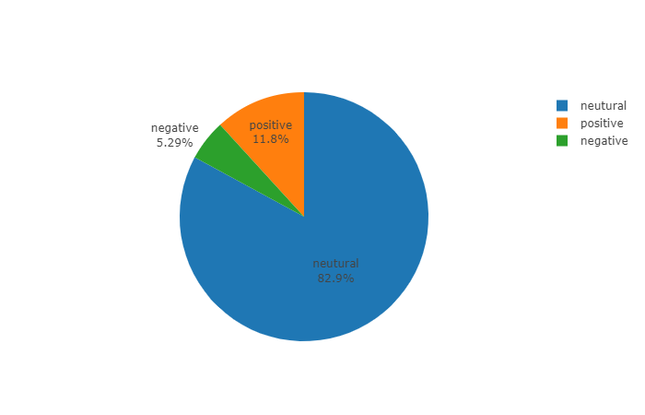
Figure 3. Sentiment Analysis for aggregated text
In the same fashion, VADER algorithm can be applied to each single row of text/record, and the four sentiment metrics will be produced accordingly. A preview of the sentiment scores are available on the web page (Figure 4). The same results will be saved as a ".CSV" file for download purpose.
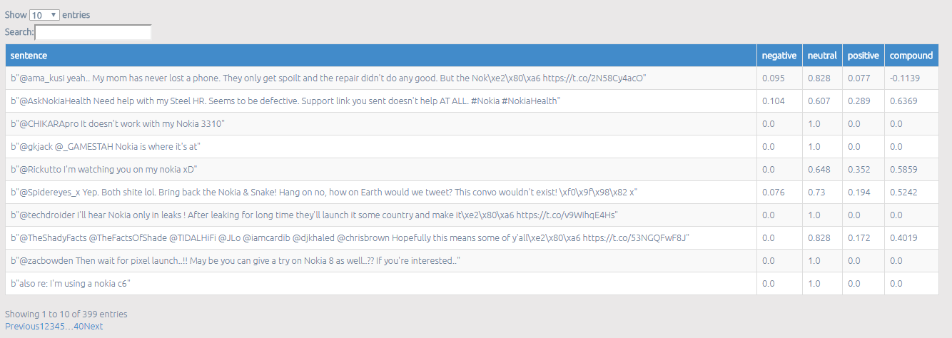
Read as 10.4%, 60.7% and 28.9%
Field that you choose to perform sentiment analysis on
Figure 4. Sentiment Analysis for each record

- Introduction about Valence Aware Dictionary and Sentiment Reasoner (VADER)
VADER is a simple rule-based model for general sentiment analysis. A gold standard list of lexical features along with their associated sentiment intensity measures are established and are specifically attuned to sentiment in microblog-like context. In another word, VADER can recognize the emotion associated with internet slang, acronyms, and emoji quite effectively. VADER out-performed 11 typical state-of-art benchmark algorithms, including LIWC, ANEW, the General Inquirer, SentiWordNet, and machine learning based methods.
For more information, please read their publication: Hutto, C.J. & Gilbert, E.E. (2014). VADER: A Parsimonious Rule-based Model for Sentiment Analysis of Social Media Text. Eighth International Conference on Weblogs and Social Media (ICWSM-14). Ann Arbor, MI, June 2014.

